Invoice Generation
- O’Connor will invoice the property owners based on the property reduction values.
- Generally, invoices will generated based on the terms and remarks of the accounts qualified for invoicing.
- Invoices will be queued only when the hearing is finalized.
- After finalizing, invoices will be queued automatically as per its invoice type.
- Invoices are classified in three levels :
- Account Level
- Project Level
- Term Level/Group Level
- Invoice will be generated and queued based on the Invoice level set in the group associated for respective account number
- Invoices are calculated by the values, contingency and tax rate.
- Invoice copy will be validated before generating the invoice from the queue.
- Invoices are generated based on the remarks mentioned in the terms remarks tab.
- If the client is over 65 we will consider the contingency as 25%. The other contingencies like 10%, 20%, 40% are given as per the remarks mentioned and 15% are given for the lifestyle members.
- Invoices will not be qualified if the jurisdictions are blank.
- We cannot invoice the client, if the hearing is not attended by OCA.

Invoice Levels:
Account Level:
- Account level invoice will have only one account information in the invoice copy.
- The account will be queued for invoicing when the hearing gets finalized.
- In account level invoicing, the invoices are generated for each property individually.
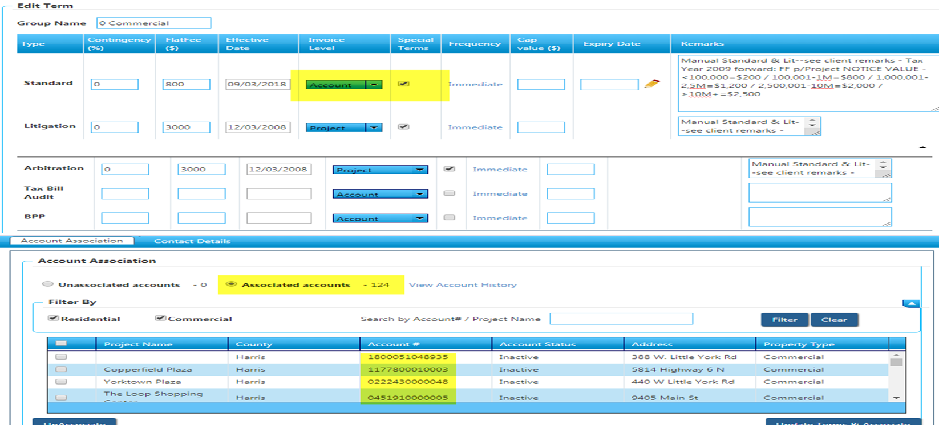

Project Level:
- Project Level invoice will have project name and particular project accounts information in the invoice copy.
- The records will be queued for invoicing only when the complete accounts gets finalized under the specified project. Until then the record will not be queued for invoicing.

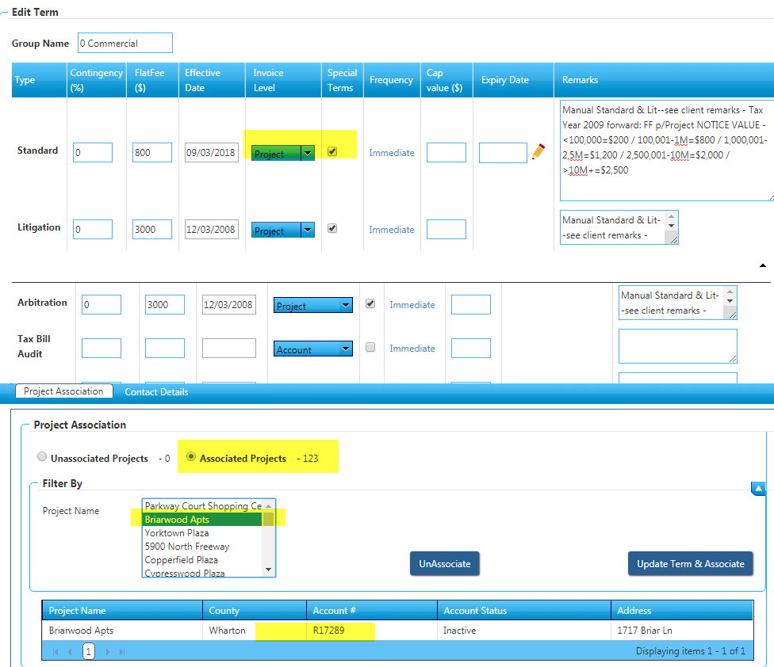
Term/Group Level:
- Term level invoice will be generated only when all the accounts gets finalized under the respective group.
- All the associated accounts will be listed in the invoice copy.

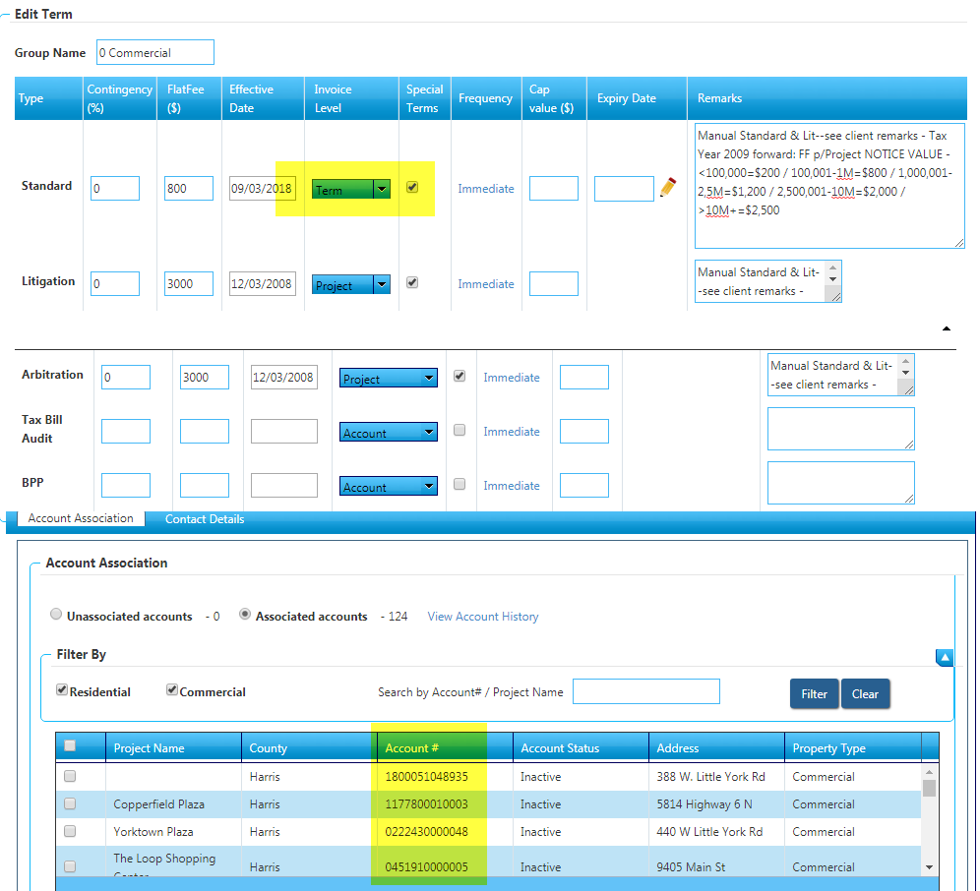
Invoice Queue Types:

- Standard Regular Invoice
- Litigation Regular Invoice
- Arbitration Regular Invoice
- Litigation Defect Invoice
- Arbitration Defect Invoice
- Standard Special Invoice
- Litigation Special Invoice
- Arbitration Special Invoice

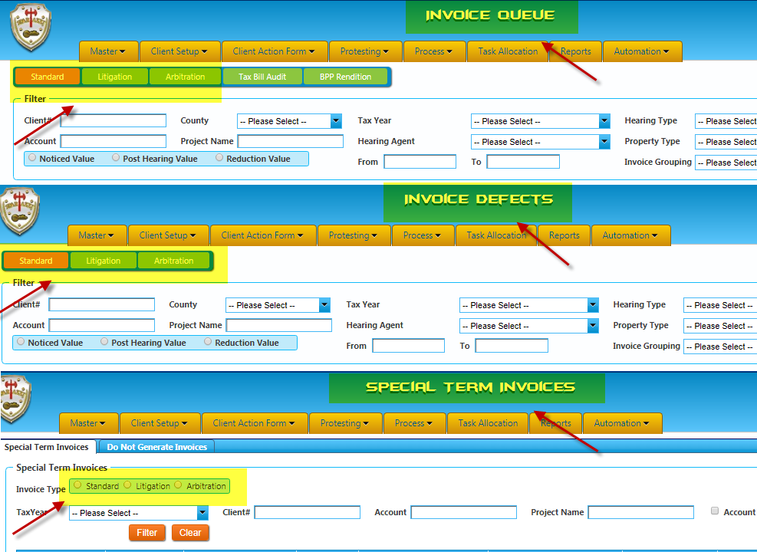

Standard regular Invoice:
- Initially, the client will protest in this invoice type for his property if he is not satisfied with the reductions in standard type he will choose either litigation or arbitration.
- In standard invoice, it is validated by the contingency, tax rate, jurisdictions, values of the property and the reduction for the property.
- Invoices are not qualified if the invoice amount is “Amount<5”.
- Invoices are sent based on the remarks mentioned in the remarks tab.
- Invoices can be generated by selecting multiple accounts and also in single account. The multiple accounts selection option is available for all the type of regular invoice generation.
- Invoices will move out from the queue when we select the “Send invoice now” option and those invoices will be stayed in corr-queue which will be generated as per the default delivery method of the client.
- Once the corr-queue run process completed invoices will sent to the client based on the client delivery method.
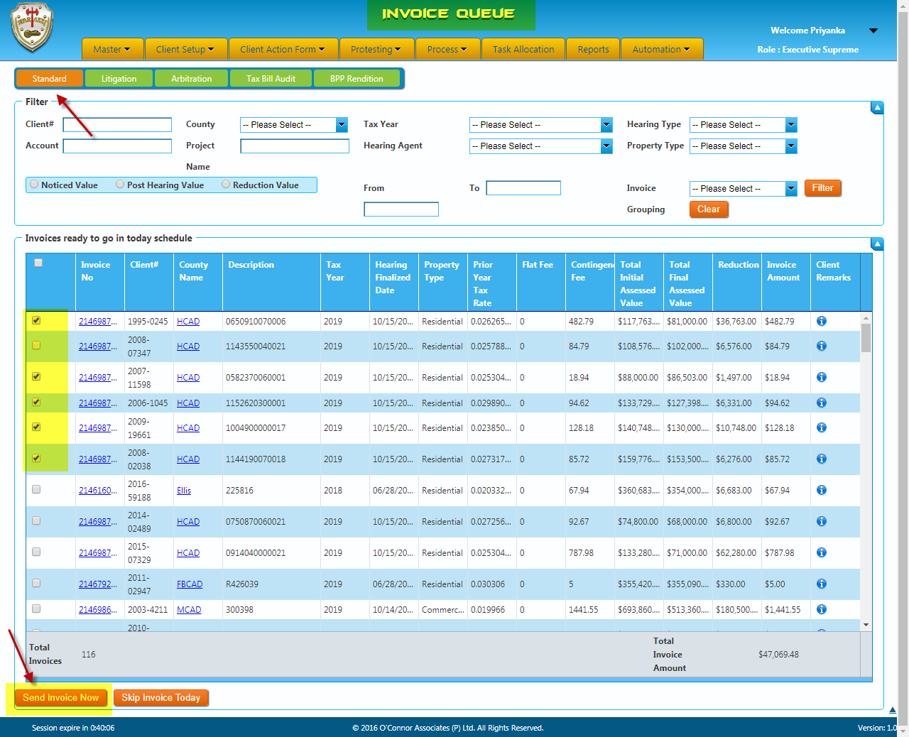

Litigation Regular Invoice:
- Litigation invoicing is another type of invoicing.
- In litigation regular invoice, it is validated by the Litigation status, Settlement date, HRinvoice status, Contingency, remarks, Tax rate, Values and Prior year invoice details to confirm whether the account is eligible for invoicing.
- Litigation invoices are queued once the particular account is Lit finalized.
- If the litigation status is “Settled, EXP - Settled” the account is qualified for invoicing.
- While generating, if the litigation status is “Pending litigation, To be filed, No litigation Filed, Dismissed, No suit, EXP – Settlement in progress” we will not generate the invoices for those accounts from the litigation invoice queue.
- If the accounts are qualified for invoicing, the invoices will be generated as like as Standard regular invoicing.
- The multiple accounts selection option is available for all the regular invoice generation.
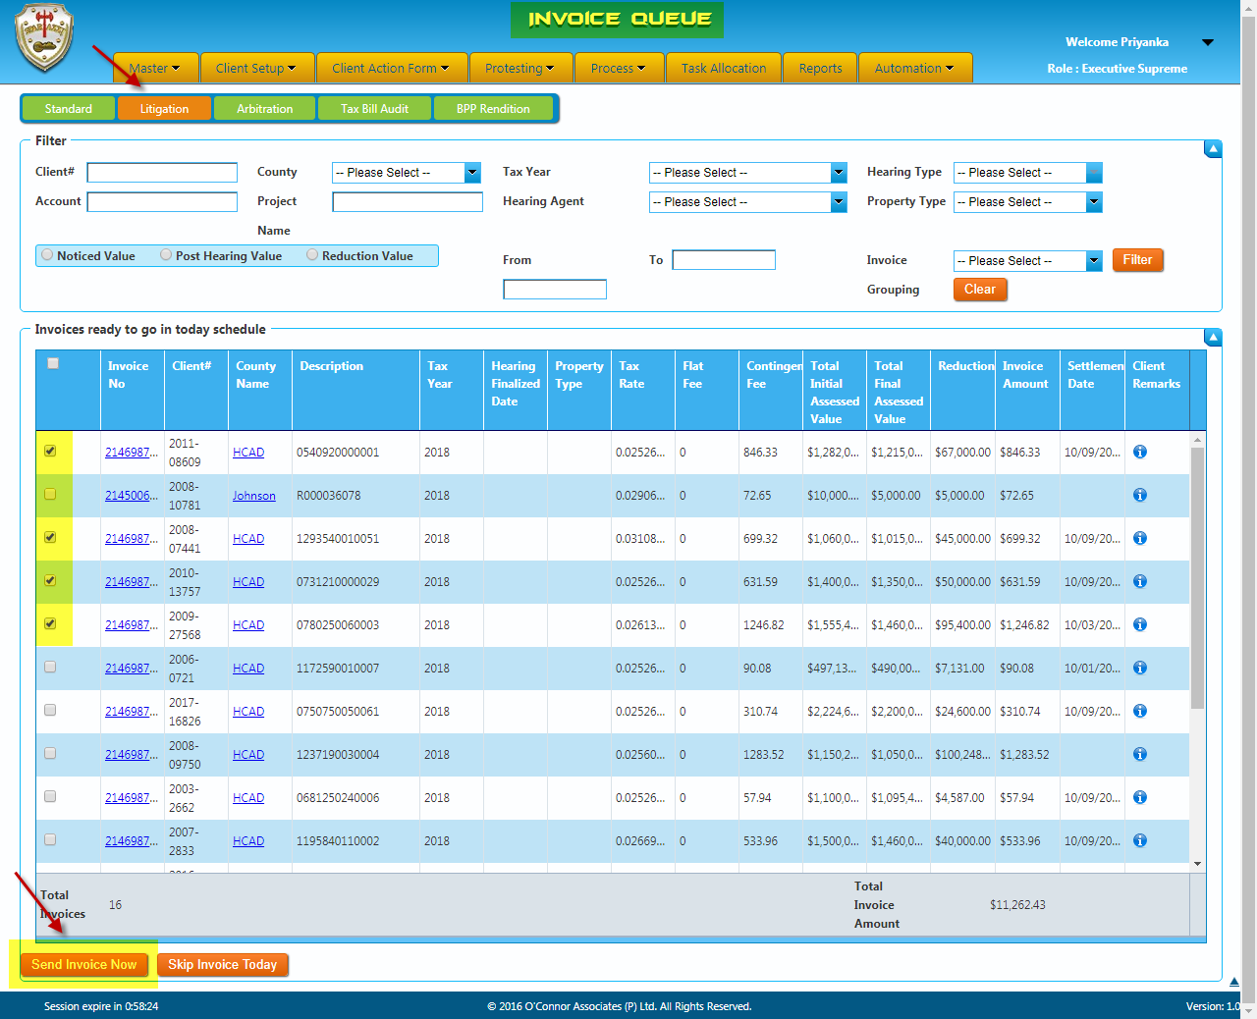

Arbitration Regular Invoice:
- In arbitration regular invoice, it is validated by the Arbitration status, HRinvoice status, Contingency, remarks, Tax rate, Values and Prior year invoice details to confirm whether the account is eligible for invoicing.
- Arbitration invoices are queued once the particular account is Arb finalized.
- If the arbitration status is “Awarded (Won/Loss), Settled (Won/Loss)” the account is qualified for invoicing.
- While generating, if the arbitration status is “Pending, Withdrawn, Not filed, No show” we will not generate the invoices for those accounts from the arbitration invoice queue.
- If the accounts are qualified for invoicing, the invoices will be generated as like as Standard regular invoicing.
- The multiple accounts selection option is available for all the regular invoice generation.
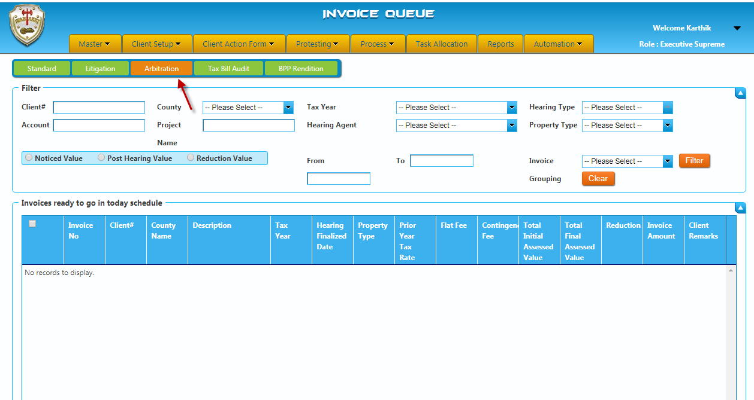

Litigation Defects Invoice:
- Invoices which are below the tax rate 2.5 and which has remarks in terms remarks tab will be queued under this queue.
- As like as litigation regular invoices, we need to validate each status of the particular account and send from the queue.
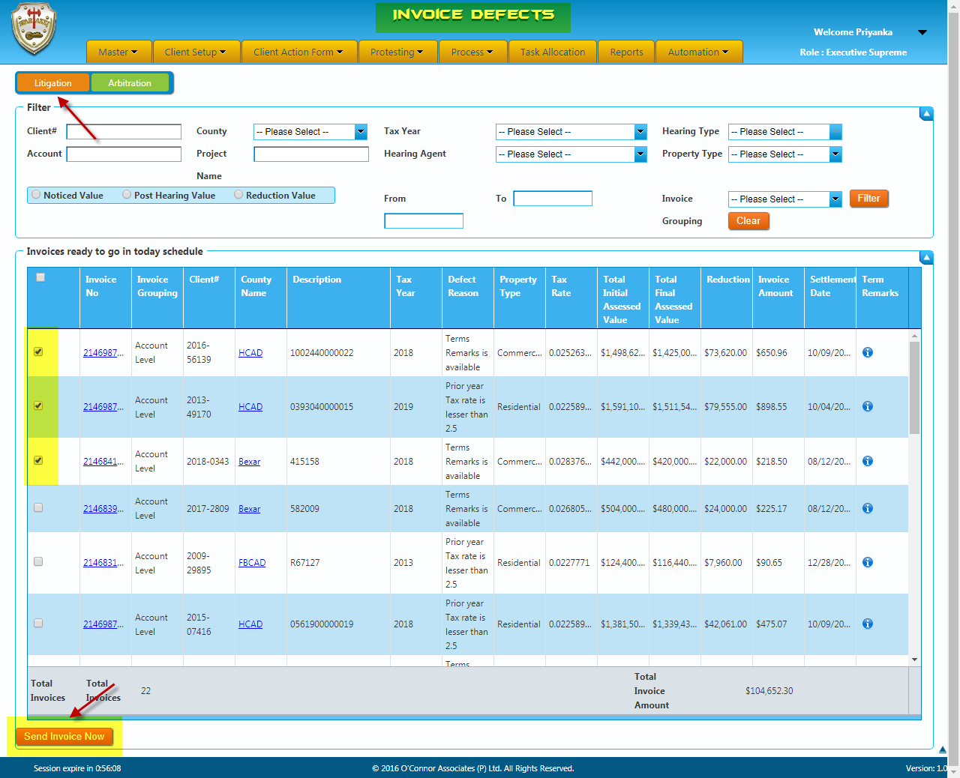

Arbitration Defects Invoice:
- Invoices which are below the tax rate 2.5 and which has remarks in terms remarks tab will be queued under this queue.
- As like as arbitration regular invoices, we need to validate each status of the particular account and send from the queue.
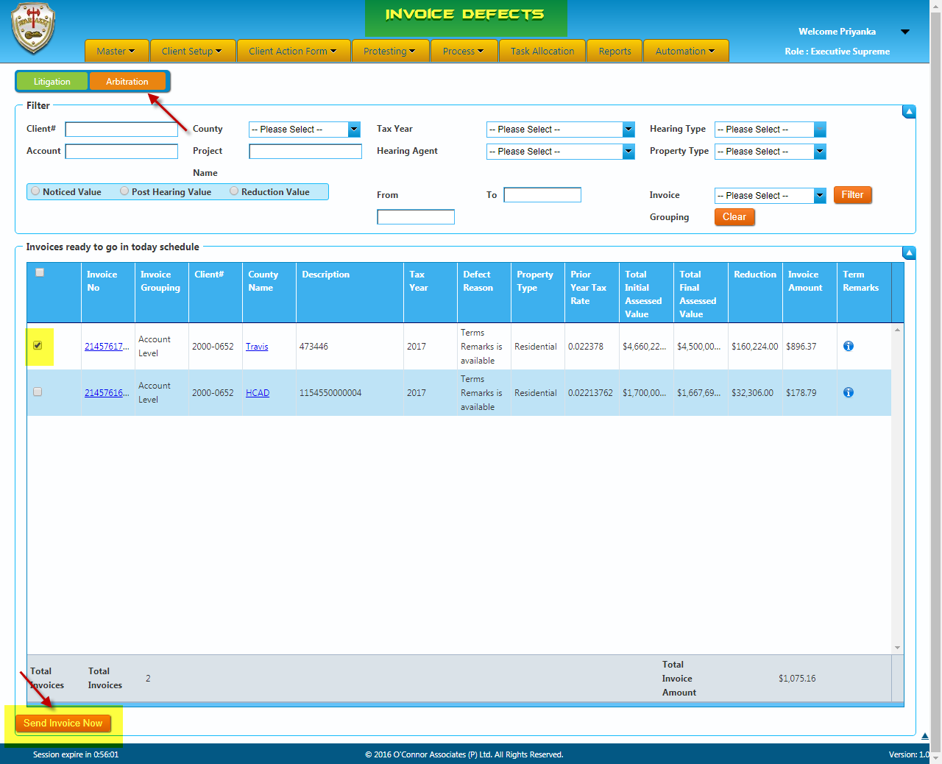

Types of fees:
- Contingency
- Flat Fee
- Capped Fee
- Combination of all above fees
Contingency Fee:
- Normally a fee will be calculated based on the % mentioned in the terms from estimated tax savings.
- The default fee will be 50% and it may vary depends upon the property value/no of properties the client has.
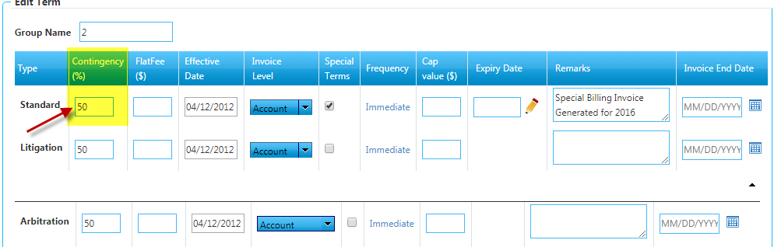
Flat Fee:
- An invoice with the flat fee will be generated irrespective of the tax savings. This includes no change as well.
- If we do not have contingency fee, we should generate the invoice with flat fee based on the remarks in that particular terms type.
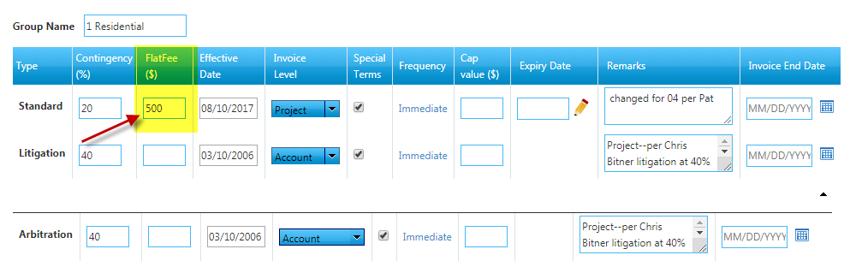
Cap Fee:
- This is mentioned for some particular clients as per agreement.
- In this fee condition invoice amount should not exceed the particular fee mentioned in the cap fee term. i.e., if the invoice amount is $5000 and the cap fee is $2500, invoice should be sent to the value $2500. Whichever is lower condition.

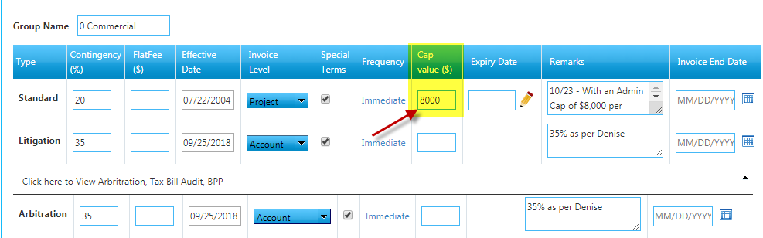

Special Term Invoice:
The records which are marked as “Special Terms” will be queued in the special queue where the needs to read the comments mentioned by the agent/consultant before generating the invoice.

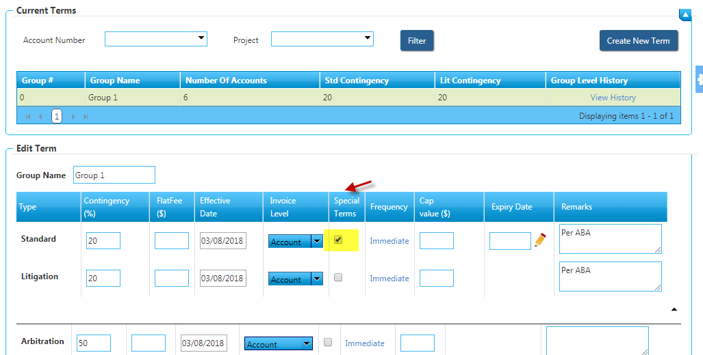

In special invoicing we have three methods of generating:
- Generate
- Do not generate
- Sent to Option using mail id “spartaxxinvoices@poconnor.com”.
Standard Special Invoice:
- Usually, special invoices will be handled for Commercial clients which has flat fee or cap fee project level.
- In standard special invoice, it is validated by the codes remarks (Client remarks), terms remarks, contingency, tax rate, values of the property and the reduction for the property.
- Invoice copy will be validated before sending the invoice from the queue.
- Invoice can be generated only one at a time based on the invoice level.
- If invoices are generated using the generate option, invoices will move out from the queue and those invoices will be stayed in corr-queue which will be generated to the client as per the default delivery method of the client.
- Once the corr-queue run process completed, invoices will sent to the client based on the client delivery method.
- In special invoicing, even if the invoice amount <= 5 and contingency fees “0” invoice will be queued.
- Some category of invoices will be sending to Do not Generate option, if the invoice should not send to the client.
- If the term remarks or the client remarks mentioned as “sent to Denise, Denise will pull invoices” invoices will be generated using “Sent to” option invoices will move to the email “spartaxxinvoices@poconnor.com”.
- If there is any cap fee mentioned for a particular account (eg: 5000, 7000 etc), invoice amount should not exceed the cap fee.
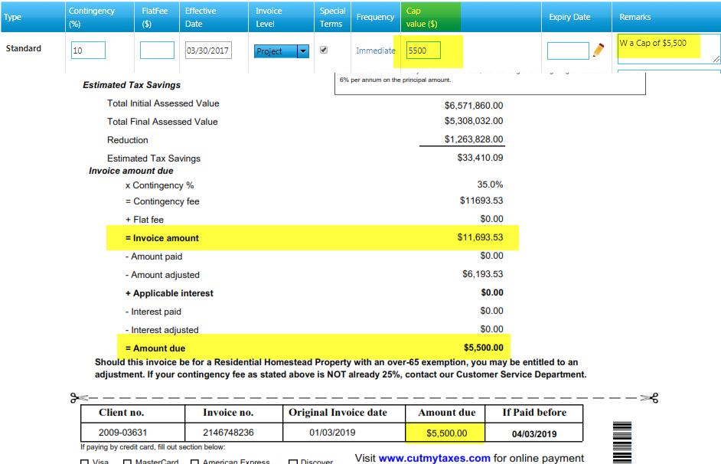
- If there is any flat fee mentioned for the account, it will be added to the invoice amount. For example: If the flat fee mentioned is $100 and the contingency fee is $1000 then the invoice amount will be calculated as $1100.
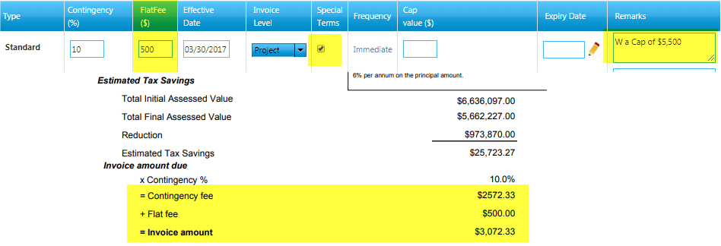

Litigation Special Invoice:
- Litigation special invoice is as same as the standard special invoice.
- In litigation special invoice, it is validated by the Litigation status, HRinvoice status, Contingency, Client remarks, Term remarks, Tax rate, Prior year invoice details, Values of the property and the Reduction for the property.
- Invoice copy will be validated before generating each invoice from the queue.
- Invoices are sent based on the remarks mentioned in the remarks tab.
- Invoice can be generated only one account at a time.
- If invoices are generated using the generated option, invoices will move out from the queue and those invoices will be stayed in corr-queue which will be generated to the client as per the default delivery method of the client.
- Once the corr-queue is generated invoices will sent to the client based on the client delivery method.
- In special invoicing, even if the invoice amount <= 5 and contingency fees “0” will be queued.
- Some category of invoices will be sending to Do not Generate option, if the invoice should not send to the client.
- If the term remarks or the client remarks mentioned as “sent to Denise, Denise will pull invoices” invoices will be generated using “Sent to” option invoices will move to the email “spartaxxinvoices@poconnor.com”.
- If there is any cap fee mentioned for a particular account (eg: 6000, 10000 etc), invoice amount should not exceed the cap fee.
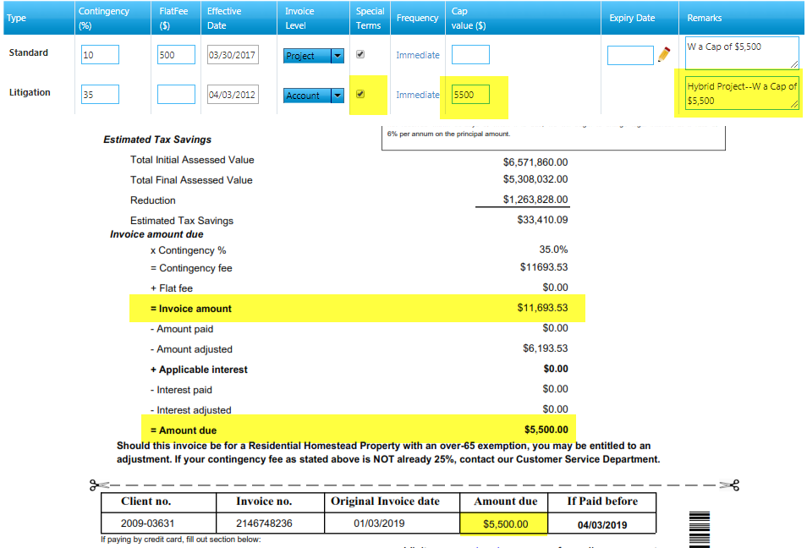

Arbitration Special Invoice:
- Arbitration special invoice is also as same as the standard special invoice.
- In arbitration special invoice, it is validated by the Arbitration status, HRinvoice status, Contingency, Client remarks, Term remarks, Tax rate, Values of the property and the Reduction for the property.
- Invoice copy will be validated before generating each invoice from the queue.
- Invoices are sent based on the remarks mentioned in the remarks tab.
- Invoice can be generated only one account at a time.
- If invoices are generated using the generated option, invoices will move out from the queue and those invoices will be stayed in corr-queue which will be generated to the client as per the default delivery method of the client.
- Once the corr-queue is generated invoices will sent to the client based on the client delivery method.
- In special invoicing, even if the invoice amount <= 5 and contingency fees “0” will be queued.
- Some category of invoices will be sending to Do not Generate option, if the invoice should not send to the client.
- If the term remarks or the client remarks mentioned as “sent to Denise, Denise will pull invoices” invoices will be generated using “Sent to” option invoices will move to the email “spartaxxinvoices@poconnor.com”.
- If there is any cap fee mentioned for a particular account (eg: 4000, 9000 etc), invoice amount should not exceed the cap fee.
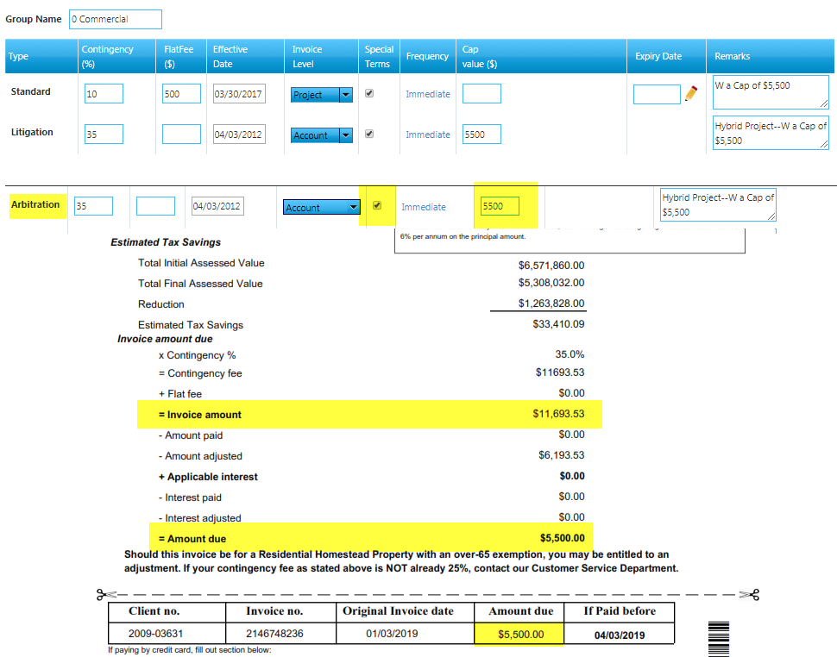

Pending Group Invoice:
- Accounts under the term level and project level invoicing must be qualified for invoicing.
- If the accounts under the particular project or term level invoices not qualified, those invoices will be moved under this queue until all the accounts under the term or project qualify if it has not checked special terms check box.
- Once all the accounts are qualified, we need to select the particular account and select “Generate invoice” option to move the invoices to invoice generation queue.
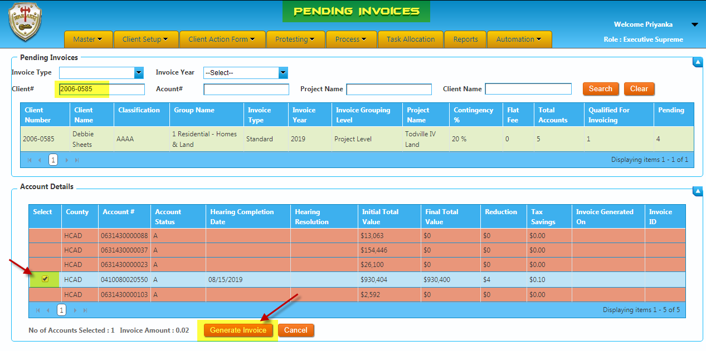

Calculation of Invoice Fee:
- The invoice fee will be calculated from the tax savings achieved after the Hearing.

Property value before Hearing | $500,000
Tax Rate | 2.512
Tax to be paid by the client | $12,560

Property value after Hearing | $450,000
Tax Rate | 2.512
Tax to be paid by the client | $11,304

Tax Savings | $1,256
Contingency | 50%
O'Connor Fee | $628

Sample Invoice Calculation

Particulars | Values
Notice Total Value | 1,575,688.00
Post Hearing Value | 1,000,000.00
Tax Rate (divided by 100) | 0.0534196
Contingency % | 50%
Reduction | 575,688.00
Tax Savings | 30753.02268
Invoice Amount | 15376.51134

